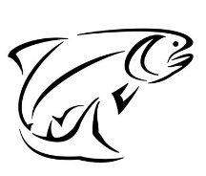
LOCHABER DISTRICT SALMON FISHERY BOARD
2020 ANNUAL REPORT
The annual report summarises the work of the Lochaber DSFB to the end of February 2021, particularly with regards to the delivery of its statutory functions, powers and responsibilities.
Membership
Clerk – Jon Gibb, Lighthouse Cottage, Gairlochy, Spean Bridge, PH34 4EQ
Tel 07786 493048. jongibb123@gmail.com http://lochaber.dsfb.org.uk

Board Members

Michael Mann (Chairman) Lochy
James Semple Shiel
Alan Kennedy Ardtornish Estate
Astie Cameron Lochiel Estate
David Gunn Angling Club Rep
Kim Malcolm Netting Representative, Cuil Bay
Andrew Shaw Lochy
David Stewart-Howitt Moidart
Grace Henderson Morar
Tom Leslie Ailort

Lochaber Trust Representative Lucy Ballantyne

Board Advisors

Allan Henderson Highland Council
Kenneth Knott Forestry Commission

Catches
Fishing was badly interrupted throughout the 2020 season due to the Coronavirus pandemic and travel restrictions. Therefore the reports were fairly mixed from all of the region’s rivers. It was a year where rod catches did not give a good indication of the strength of the runs.
On the River Lochy there was a reasonable run of both 2sw salmon and summer grilse. The majority of the salmon ran in the early summer and the grilse run had started to decline by mid-August. There were few fresh fish running in the autumn. This is a pattern which has been seen over the past few seasons. Catches were the best in 5 years in spite of the pandemic limitations.
Sea trout rod catches again showed variable results. Numbers are a fraction of what they were in the past but (as with other years) there are occasional anomalies with one or two small burns/rivers still reporting a number of large female sea trout still present.
Conservation Policy
National conservation measures applied during the 2020 season. All rivers in the region (aside from two) were assigned Grade 3 status which required 100% Catch and Release of all salmon and grilse. The Rivers Lochy and Moidart were Grade 2 which allows independent setting of rules, although it is notable that all of these rivers voluntarily return the vast majority (estimated over 97%) of all salmon and grilse. All rivers in the region also apply local voluntary rules, endorsed by the Lochaber DSFB, where 100% of all sea trout are also returned.
Due to the current national conservation measures not permitting coastal salmon netting, all levy to salmon netting station proprietors was refunded by the Board in 2020. It is proposed that this is continued in 2020.

Fisheries Protection and Bailiffs
There were 19 warranted bailiffs currently working on both a paid full-time and voluntary basis in the region in 2020.
There were no prosecutions for poaching in 2020. Although illegal fishing and poaching are currently at a low level due to fish numbers, it is important to maintain a constant vigilance and a programme of information and education. With one of the largest coastlines of all Fishery Boards in Scotland, the Board continues to seek ways of funding a proper fishery protection operation more akin to the protection afforded salmon in the East Coast rivers. There were several pollution incidents reported by local water bailiffs in 2020 and information passed on to the Clerk.

National issues

Marine Scotland Science– 2021 conservation measures and river categorisations.
The Conservation Measures for 2020 have now been set and there have been no changes from last year. All rivers in the region have been set at Grade 3 with the exception of the Rivers Lochy and Moidart which are Grade 2. The data used by Marine Scotlandfor all of the calculations on an individual river basis can be found on
file:///C:/Users/jongi/Desktop/Salmon+fishing+2021+NW+Kyle+of+Lochalsh+to+Ardnamurchan.pdf

The different categories and what they mean and what action they require is as follows-

Category | Probability of Meeting CL | Effectively CL Met in: | Advice
1 | At least 80% | 4 out of 5 years | Exploitation is sustainable therefore no additional management action is currently required. This recognises the effectiveness of existing non-statutory local management interventions.
2 | 60-80% | 3 out of 5 years | Management action is necessary to reduce exploitation; mandatory catch and release will not be required in the first instance, but this will be reviewed annually.
3 | Less than 60% | ≤ 2 out of 5 years | Exploitation is unsustainable therefore management actions required to reduce exploitation for 1 year i.e. mandatory catch and release (all methods).

 | Gradings 2020 | Gradings 2021
Ailort | 3 | 3
Aline | 3 | 3
Inverie | 3 | 3
Guiserein | 3 | 3
Leven | 3 | 3
Coe | 3 | 3
Lochy | 2 | 2
Nevis | 2 | 3
Moidart | 2 | 2
Morar | 3 | 3
Scaddle | 3 | 3
Shiel | 3 | 3
Strontian/Carnoch | 3 | 3

Atlantic Salmon Trust Smolt migration route monitoring project
The proposed project to track salmon smolts leaving West Coast rivers and try and identify their early marine migration paths (after a delay of a year due to coronavirus) has been given the go-ahead, with funding for 3 years from Marine Scotland and SSPO. In Lochaber 2 tributaries of the Lochy will be used – the Loy and the Lundy – with over 100 smolts to be acoustically tagged and then ‘listened to’ leaving the river and on their journey out to sea. The Lochaber Fishery Trust and the Lochaber DSFB are involved with the trapping and tagging of smolts and this will start on 8th April this year.
A smolt trap will also be operated on the River Moidart with the aim of measuring the size of the smolts to see if they are big enough to take acoustic tags. If so it is hoped that this river can be added to the smolt tracking project in future years.
The River Lochy Association has also paid for 4 extra receivers to be placed down the River Lochy in order to try and measure any losses in freshwater (it should be noted that the main project is only designed to track smolts in their early marine migration and is not measuring freshwater losses to predation etc).
The marine receivers are currently being deployed at sea and the freshwater Lochy receivers will be placed in the river within the next fortnight.
The main receivers, arrays and participating rivers can be seen in the map below.
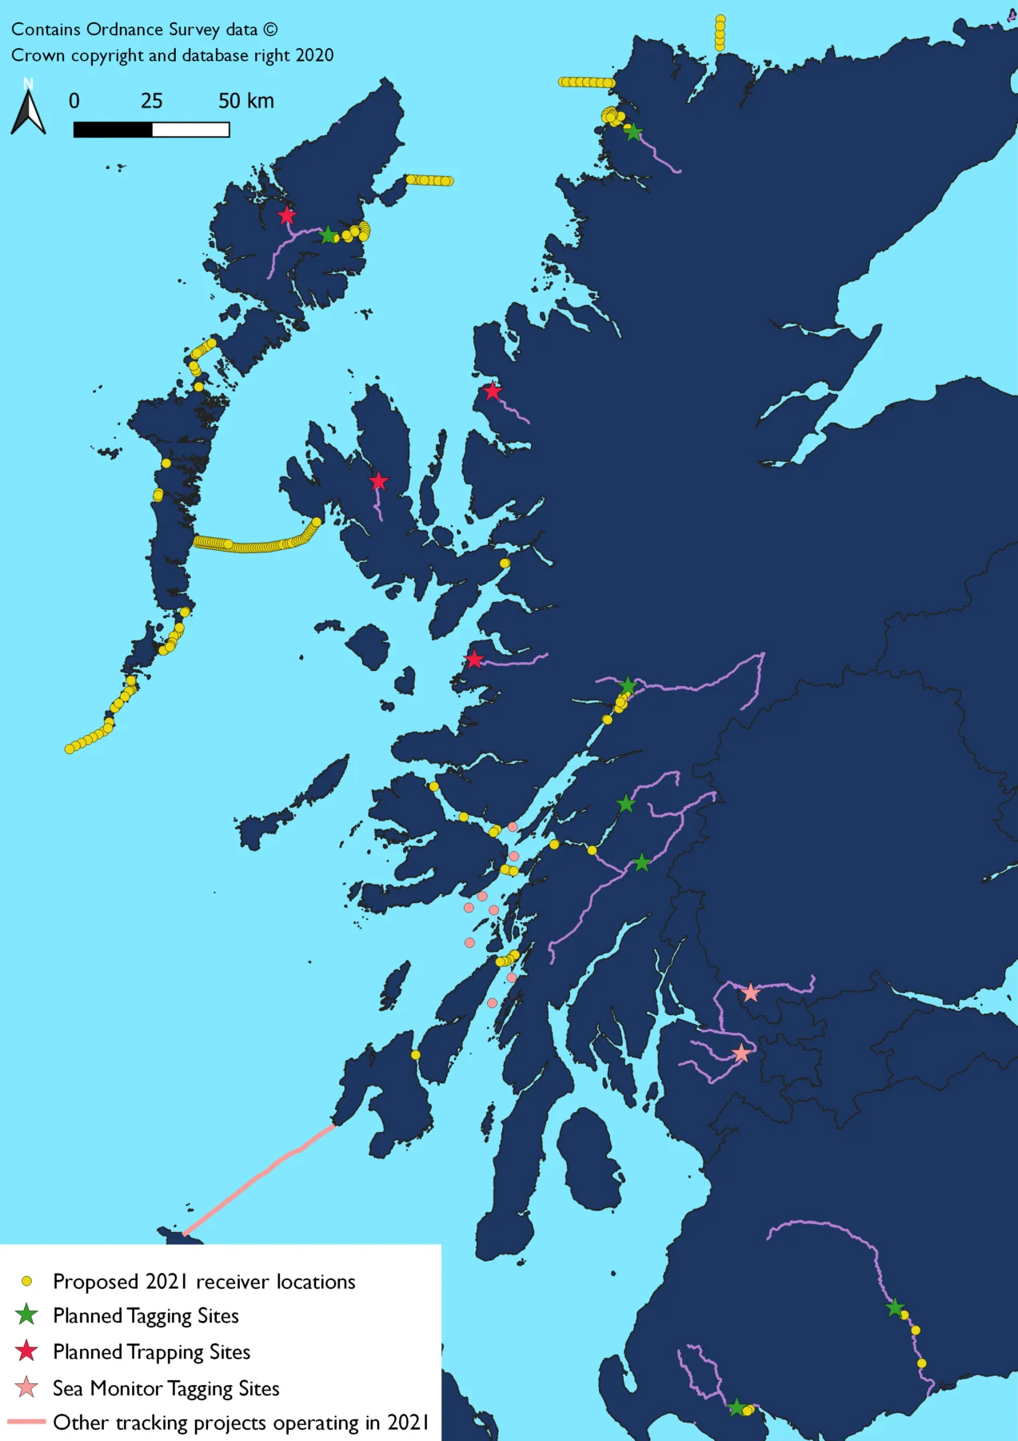

Aquaculture and Freedom of Information requests
The Board has been facing increasing numbers of Freedom of Information requests from fish farm activists including staff at Trout and Salmon Conservation Scotland (S&TC). This is as a result of the Information Commissioner deciding last year that Fishery Boards were ‘public bodies’ for the purposes of the Environment Regulations and could therefore be asked for any information under these regulations. This was vehemently opposed at the time (how can an organisation be a public body if it receives no public funds) but our complaints fell on deaf ears. It is a highly damaging development for all poorly funded Boards.
These requests have been asking for exact details and copies of past telephone conversations, messages, emails, meetings, minutes and documents. There are significant fines and potential criminal charges for not complying fully with these requests. All of the requests have been linked to aquaculture.
The Board does not have the resources with one part-time Clerk to deal competently and legally with these types of requests – with each one taking up a huge amount of time and research. Now that this avenue has been opened to activists it is expected that there will be a deluge of such requests over the coming months and years (other Boards are also experiencing this.)
Therefore it has been decided that the lead body on all matters pertaining to aquaculture will now be the Lochaber Fishery Trust and the relevant local Fishery Manager. All relevant documents received by the Board will be forwarded to them upon receipt. The Lochaber DSFB will remain a signatory on all statutory documents such as major planning responses and Environmental Management Plans but the preparation and negotiation surrounding such documents will not be undertaken by the Clerk to the Board directly but by the Fishery Trust and the local Fishery Managers. All future requests for information under the Environment Regulations will be directed to the Trust and any relevant parties dealing with these matters. Statutory documents signed by the Clerk to the Fishery Board will still be available upon request by applicants using the Environment Regulations.

Summary of work undertaken up to end February 2021
(please contact the Clerk if you require the details of any of these items)

- Further discussion with MOWI surrounding the Muck fish farm monitoring by their agents APEM (see previous reports) – the monitoring has been supported for another year but only on condition that fish counter on the River Moidart is fully scoped and costed by MOWI. This will provide long-term and effective monitoring (unlike the APEM work) and also provide wider benefits for the region. MOWI have agreed to cost and scope counter. I have approved another year of monitoring at 4 sites

- EMP reporting protocols for all regional EMP’s discussed with Stephen Macintyre (MOWI Environment Manager) – a traffic light system is being proposed to inform adaptive management

- The Report of the Interactions Working Group (which was a result of the Salmon Farming Inquiry) was circulated to all members. This summarises a more robust regulatory regime for all fish farms. This will now be presented to Scottish Ministers.

- There was a suspected escape of parr from Loch Lochy fish farm in August as I witnessed a build-up (up to 500 fish) of uniform sized fish above Mucomir Power station. I reported this to MOWI senior management and site visits were undertaken. No samples were possible due to the location of the fish by the power station. MOWI records showed that a count had been undertaken and that no losses were recorded at the site. I remained uncomfortable about the situation but by the time I did another visit the fish had gone. Ongoing visual checks are being undertaken and will continue throughout the autumn. (It should also be noted that the LFT genetic introgression project should also highlight any escaped fish in the local juvenile populations).

- The Aquaculture Stewardship Council (ASC) accreditation process for the MOWI Linnhe Leven and Gorsten sites has started and the DSFB has been invited to feed into this. A response and ongoing involvement will be coordinated with the LFT.

- Planning apps for Lismore and Rum being coordinated by LFT/Argyll FT and Polly Burns at FMS
- Circulated information on coronavirus business assistance schemes and advice to workers and proprietors from Scottish Government

- Fed directly into Scottish Government’s RECCE Committee call for evidence on Covid’s financial impacts on fisheries businesses ie a loss of income for salmon fisheries but no available funding

- Liaised with Atlantic Salmon Trust on the delay to the West Coast Smolt Tracking Project in 2020 and (currently) setting up arrangements for the delayed start in Spring 2021

- Recorded an online podcast interview with the Atlantic Salmon Trust highlighting the West Coast Tracking Project

- Received request for information under the Environment Regulations from Mr Corin Smith regarding Lochaber DSFB discussions surrounding the SSPO Wild Salmon Fund. In spite of the fact that we do not hold this information (and the applicant was informed of this), the Information Commissioner was involved. As a result, I have received legal opinion from FMS/Fishlegal on the Environment Regulations and the implications for all DSFB’s.
- Contacted all Lochaber Angling Clubs with a call for nominations to fill the vacancy for the Angling Club member of the DSFB following the death of Iain Donnellly. Received 2 nominations which will be put to Board members in September.

- Due to the ongoing Covid crisis the Scottish Government issued guidance on DSFB’s legal requirements on Good Governance legislation in light of the crisis. As a result of the guidelines received the decision was taken to hold the 2020 AGM by email communication instead of face to face

- Investigated a report of unlicensed bank works on the River Morar and discussed issues with proprietors on both banks and advised on legal requirements

- Investigated and reported to SEPA the complete destruction due to bankside works of a section of the Caonich burn (a known spawning burn) on Loch Arkaig

- Ongoing discussions with forestry and stakeholders about a replacement for Carr’s corner bridge over the River Lundy (the bridge was removed due to a breach in the water supply pipe to Fort William).

- Distributed 2019 national catch statistics to Board members which were published in April – these included new online tools for looking at catches for river areas

- Ongoing liaison with local forestry company about repairs to the White Bridge on Loch Arkaig and potential damage to existing and important spawning beds due to scouring of the bridge abutments

- Liaison with FMS about new seal licencing arrangements – the marksman licence will now be removed but (potentially) applications for targeted culling can be made where specific damage in freshwater can be demonstrated (details to follow

- Following ongoing works and road closures at the Black Parks (tidal water River Lochy), access for angling negotiated with local council and Jahama Estates.

- Met with the new team at Jahama Estates to discuss a range of fisheries issues on the Estate

- Involved in process to assess all potential barriers to migration on the River Suileag at Fassfern Estate – developers wish to expand the existing hydro and gather more water
- Coe river new road bridge proposals – advised on in river working and minimising impacts on working at night during smolt and adult runs
- White Bridge at Loch Arkaig – further negotiations on work to fix erosion problems after initial work to replace the bridge
- Canal lock at Gairlochy is being repaired – dewatering of lock required – advised on how best to go about this to minimise impact on fish
- Fish farm activist Don Staniford made EIR request for information on funding from fish farmers to the Board – responded information not held as the Board has received no funding from fish farmers
- Guy Linley-Adams, solicitor for S&TC – EIR request for all meetings, documents and telephone calls, minutes etc. on EMP’s. Forwarded Macleans Nose EMP but said we are exempt from providing information on others as they are not complete. Linley-Adams was not satisfied with response so I asked the Chairman to review the decision. The InformationCommissioner then got involved and I pointed out that he had already been sent the only existing EMP (all others are still being negotiated). Ongoing.
- Responded to consultation on hatchery stocking policy by Marine Scotland and attended online meeting – further consultation to take place this Spring prior to the publication of a new Scottish Government salmon stocking policy
- Coire Glas proposed pumped storage scheme - water rights granted by Scottish ministers – none of the points raised by DSFB appear to have been addressed – can only hope that at the CAR Licence stage we can make detailed representations that will be considered by SEPA
- Flood defence at Caol – input and site visits with pre-construction contractors. Ongoing.
- Ground investigations at bridge over River Finnan at Glenfinnan approved as no expected impact on fish
- Scottish Government announced that non-domestic rates valuations will now take place every 3 years instead of 5 years – this is used by DSFB for levy – there is also a fine if proprietors do not respond to the valuer if he requires information within 28 days
- Kiachnish bridge repairs – informed the proprietor – quite major works but fish passage maintained at all times. Ongoing discussions with BEAR Scotland
- River Strontian eyed ova stocking application authorised
- River Shiel eyed ova stocking application authorised
- Further stocking licences issued for the River Roy, Lochy, Loy, Lundy, Cour and Loch Arkaig.
- Marine Scotland announced a new licencing regime for seal control – distributed details to interested parties. Details available on request.
- Liaised with RLA Manager on Scottish Water activities at bottom of the Lochy and potential excavation of water supply pipe across the Lochy. Ongoing

Stocking consents
Stocking applications for the following catchments were approved in 2020 – Lochy, Shiel, Spean, Arkaig and Roy.
Although the DSFB is the issuing authority for stocking consents, anyone considering stocking of any sort should be aware that the application must be preceded by an application to Scottish Ministers to remove adult broodstock at any time on a Grade 3 river or after 31st October on a Grade 1 or 2 river. The advice is as follows (which should be read in conjunction with the Conservation Regulations which make it illegal to remove any salmon on a Grade 3 river) -
Parties seeking consent to collect wild brood-stock, rear their progeny and release them into a freshwater river or loch system must –
- Apply to Scottish Ministers for a licence to catch wild broodstock if such an activity is planned after 31st October (it is illegal not to have this licence in your possession before netting broodstock);
- Specify the origin of the fish from which stock will be taken;
- Where those fish will subsequently be released and at what life stage;
- Provide evidence to support the need for artificial intervention and demonstrate that the stock and carrying capacity is sub optimal. This should include evaluation of any negative effects on existing wild fish populations;
- Provide an evidence base to clearly state anticipated outcomes from the programme;
- Provide a description as to how the effectiveness of the action will be monitored;
- Taking account of brood-stock removal, demonstrate that sufficient numbers of adult fish are left to support natural production from that area;
- Record mortalities (including loss of adult brood-stock, and ova and fry from hatchery);
- Report on the outcome – what was the measured effect by monitoring the outcome?
Furthermore, should any manager plan to trap smolts in a Grade 3 river for hatchery purposes then it is possible that permission would also be required form Scottish Government. Please get in touch with the Clerk in these circumstances.

Priorities for 2021

The Lochaber DSFB will continue to work with all other stakeholders for the improvement of Lochaber’s salmon and sea trout. The DSFB will work particularly closely with the Atlantic Salmon Trust in 2021 in their smolt tracking project workstream.
The Lochaber DSFB will continue to deliver its statutory function to the best of its abilities, using all of the available powers wherever necessary to protect and enhance migratory fish in the Lochaber region.
Mindful of the perilous state of all Lochaber salmon fisheries, the Board will continue to aim to keep proprietor levy as low as possible, the aim of any saving being for proprietors to invest locally in the research and management of their fisheries through their local sub Boards and management groups. The Board will continue to support this practical management of the fisheries while offering a central administrative facility through their part-time Clerk (principally in the issue of bailiff warrants, stocking consents, responses to national consultations and dealing with local consultations of a regional importance).
The Board will continue to engage with all stakeholders for the improvement of migratory fish and these will likely include (amongst others) the fish farming industry, the Scottish Government, the hydro-electric industry and local fishery interests. The Board will also continue to work closely with the biologists at the Lochaber Fisheries Trust and assist this charity in their ongoing local projects researching migratory fish.

Complaints to the Board
There were no complaints received by the Board in 2020.

Good Governance compliance
Meetings
The annual meeting of qualified proprietors was held by email in October 2020. This meeting was publicised on the Board’s website and a copy of the notice was sent to the Scottish Government. The minutes from this meeting can be viewed on the Board’s website.
The annual public meeting for 2021 will be delayed until the end of the coronavirus restrictions. A replacement email meeting will be held in March 20201. This meeting has been publicised by means of the Board website.
Annual Report and Accounts
This annual report will be published on the Board’s website and a copy sent to Scottish Government.
The accounts for 2020 are published on the Board’s website and a copy will be sent to Scottish Government.

Complaints
The Board has set up and maintains a complaints procedure which can be viewed on the Board’s website. This has been sent to the Scottish Government. Details on the number of complaints and how they were disposed of are included above.
Members’ interests
The register of members’ interests is available from the Clerk on request. We have included a standing item at each Board meeting inviting Board members to declare new/amend existing interests and all such instances are recorded in the minutes of these meetings.

